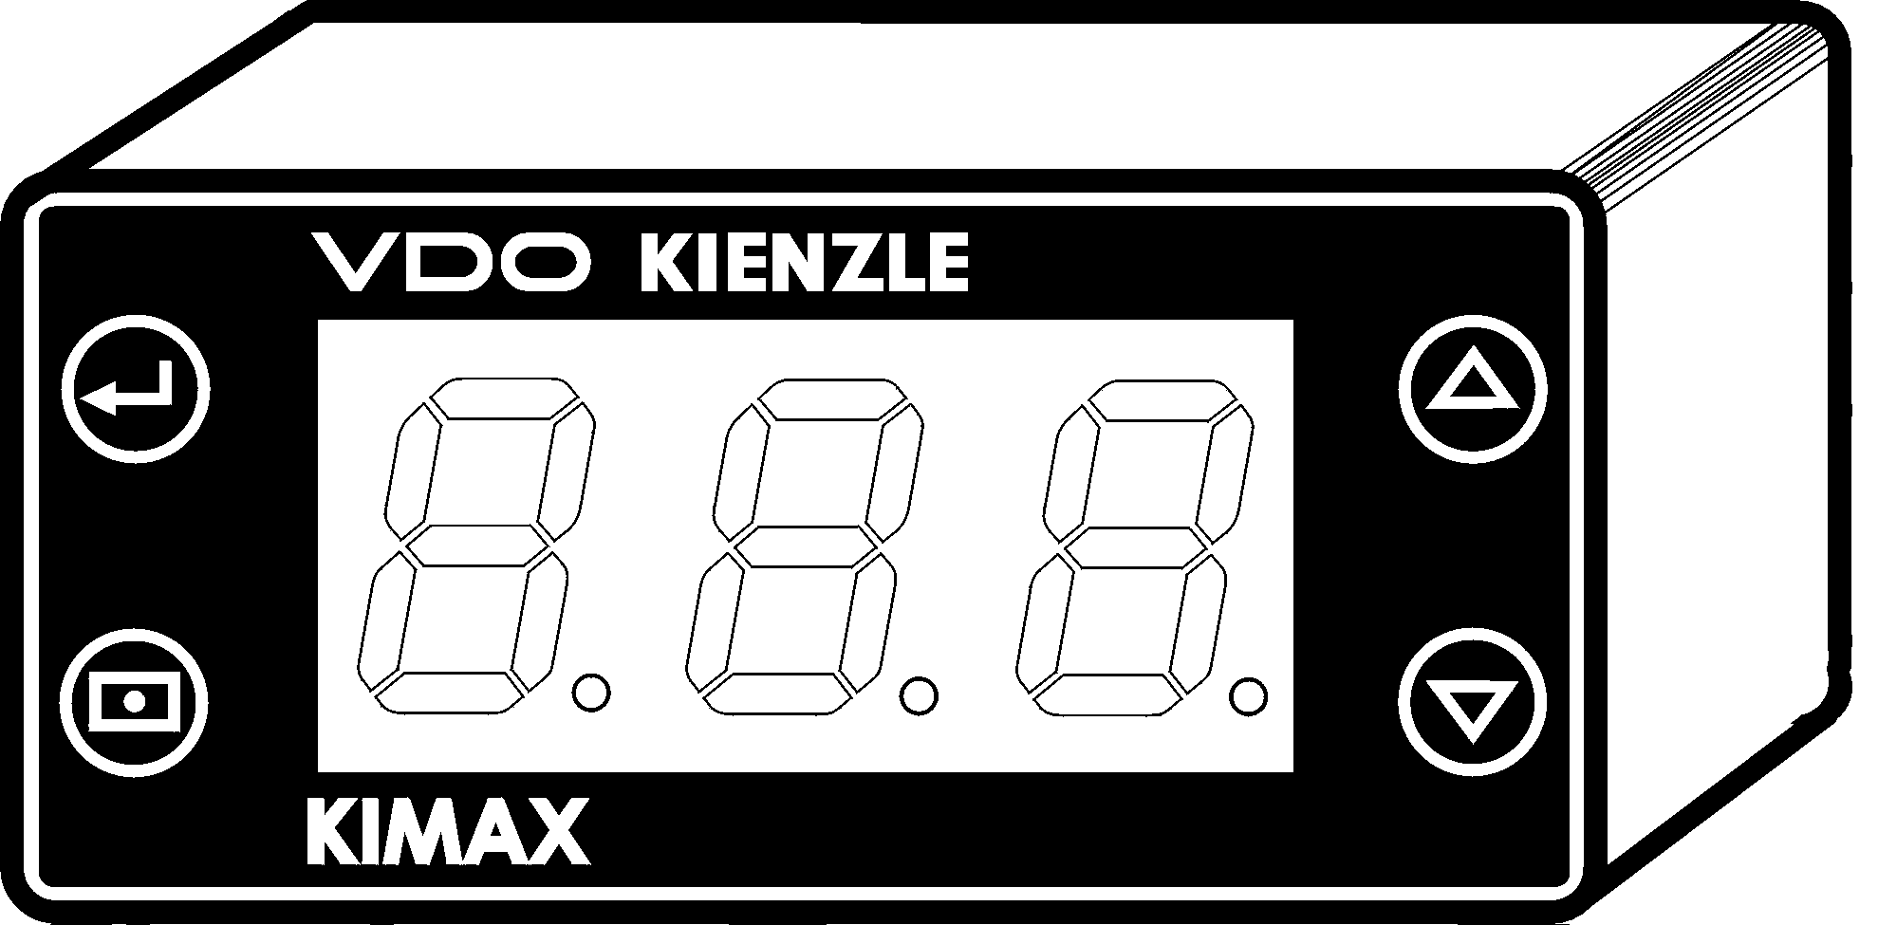
KIMAX Unit
1
2
A
B

Lock of calibration setting!

- Press key 1 and hold!
- Press additional key 2 and hold!
- Hold both keys for min. 5 seconds!
- Now the display turns to flash!

The calibration setting is locked!

Unseal lock of setting!

Please be aware that units before 01/2001 can only be unlocked by hard reset(only by manufacturer!)!

Units above 01/2001 can be unlocked with the following operations!

- Switch off power supply!
- Press key A and then B together Key # 2 and hold!
- Switch on power supply!
- Now the display shows firmware release 1,2, or 3! (Release 2 for usual KIMAX!)
- Please change with key A or B (up/down) to release 1!
- Enter key 1 for quite!
- The setting is now cleared and unlocked!
- Switch off power supply again!
- Press key A and then B together and hold!
- Switch on power supply!
- Now the display shows firmware release 1!
- Change with key A to release 2, for usual KIMAX operation!
- Enter key 1 for quite!

Now the units is unlocked and the usual KIMAX firmware release is choosed.

Produktteam Fuhrparks

Michael

Gut

KI43V1/PTF

